**IN-HOUSE PRACTICAL TRAINING**

ON

**TITLE: A Comprehensive Study Of Artificial Neural Networks**

**AMITY SCHOOL OF ENGINEERING & TECHNOLOGY**

**Submitted By: Vivisha Singh**

        (A2345918014)

**Name of faculty guide:** DR. SHILPI SHARMA



**AMITY UNIVERSITY UTTAR PRADESH**

**GAUTAM BUDDHA NAGAR, NOIDA**

**Declaration by the student**

I, **Vivisha Singh** student of **B.Tech** **(CSE) EVENING** hereby declare that the project titled **A Comprehensive Study Of Artificial Neural Networks** which is submitted by me to the Department of Computer Science & Technology, **AMITY SCHOOL OF ENGINEERING & TECHNOLOGY,** Noida, Amity University Uttar Pradesh, in partial fulfilment of requirement for the award of the degree of Bachelor Of Technology **(CSE)**, has not been previously formed the basis for the award of any degree, diploma or other similar title or recognition.

The Author attests that permission has been obtained for the use of any copy righted material appearing in the report other than brief excerpts requiring only proper acknowledgement in scholarly writing and all such use is acknowledged.

**DATE: __________**

**Vivisha Singh  
A2345918014**

**4CSE-EVE-1-X (2018-22)**

**Signature: ______________**

**CERTIFICATE**

On the basis of report submitted by **Vivisha Singh,** student of **B.Tech (CSE) EVENING**, I hereby certify that the report **A Comprehensive Analysis Of Artificial Neural Networks** which is submitted to the Department Of Computer Science &Technology, **AMITY SCHOOL OF ENGINEERING & TECHNOLOGY,** Noida, Amity University Uttar Pradesh in partial fulfilment for the award of the degree of Bachelor Of Technology (CSE) is an original contribution with existing knowledge and faithful record of work carried out by him under my guidance and supervision.

To the best of my knowledge this work has been submitted in part or full for any Degree or Diploma to this University or elsewhere.

**Date:**

**Name of Guide:** DR. SHILPI SHARMA

(Associate Professor)

….…………………………..

**Department of Computer Science & TECHNOLOGY**

**ACKNOWLEGEMENT**

We express our deep sense of gratitude to our respected and learned guides, **DR. SHILPI SHARMA** for their valuable help and guidance, we are thankful to them for the encouragement they have given us in completing the project.

We are also grateful to respected **DR. ABHAY BANSAL, Joint Head of Department-CSE**, for permitting us to utilize all the necessary facilities of the institution. We are also thankful to all the other faculty & staff members of our department for their kind co-operation and help. Lastly, we would like to express our deep apperception towards our classmates and our thanks to our parents for providing us the moral support and encouragement.

**_________________**

**Vivisha Singh**

**TABLE OF CONTENTS-**

|  |  |
| --- | --- |
| **CONTENTS** | **PAGE NUMBER** |
| **1.ABSTRACT** | **6** |
| **2.ARTIFICAL INTELLIGENCE: INTRODUCTION** | **7-10** |
| **3.LITERATURE REVIEW** | **11-14** |
| **4.ARTIFICIAL NEURAL NETWORKS** | **15-17** |
| **5.A BRIEF HISTORY OF ARTIFICIAL INTELLIGENCE AND ARTIFICIAL NEURAL NETWORKS** | **18-20** |
| **6.ADVANTAGES AND DISADVANTAGES OF ARTIFICIAL NEURAL NETWORKS** | **21-22** |
| **7.TYPES OF ANNS** | **23-24** |
| **8.BREAST CANCER- PROLOGUE** | **25-33** |
| **9.ANNS AND BREAST CANCER** | **34-35** |
| **10.METHODOLOGY** | **36-42** |
| **11.CONCLUSION** | **43** |
| **12.FUTURE WORKS**  **13.REFERENCES** | **44** |

**Abstract-**

Artificial Neural Networks- basically a concept, known from the field of biology where a neural network plays a principal and key role in the human body. A neuron is a unique and special biological cell that has the responsibility of information processing from one neuron to another with the assistance of chemical change and some electrical change also. It is comprised and composed of a cell body. And outreaching branches (tree-like) of two types. A nucleus which contains some information regarding hereditary traits and plasma neurons that has a hold of the molecular instruments for supplying the important materials required by the neurons, are the constituents of the cell body. Artificial neuron is primarily an engineering approach of a biological neural network or neuron.

Artificial Neural Networks are rapidly developing since they have been introduced to the world in the mid of the 20th century and according to science in our present time, we have explored the advantages of the neural networks and the problems which have occurred in the course of their creation. Also, the way the disadvantages and limitations of the artificial neural networks, although it being a developing branch of science and technology, are being eliminated and their advantages are being increased as per time, shouldn’t be ignored. Soon, they’ll become an indispensable part of our daily lives.

Now, the prediction of what will be the clinical result of the patients suffering from breast cancer and who have undergone surgery plays an important part in the medical field such as the planning of further treatment and the accurate diagnosis of the disease and its progression. Currently survival predictions are estimated by the doctors using techniques which are non-numeral.

Artificial neural networks have been proven that they are a powerful tool for dataset analyzation and evaluation where there are complications regarding interactions which are non-linear between the input data and the statistics to be predicted or information. Some studies also say that extensive experience is required to accurately interpret and analyse the images of breast and artificial intelligence assists in finding breast cancer with minor recalls and it can detect cancers in its early stage of progression. Hence in this paper we demonstrate the use of artificial neural networks in the diagnosis and prediction of breast cancer by moving headway into the various types of neural networks and their applications.

**Introduction-**

What is Artificial Intelligence?

In the words of John McCarthy, the father of Artificial Intelligence, it is the science and the engineering behind the creation of intelligent computer programs, especially intelligent machines. Artificial Intelligence, is how we achieve the task of making a computer, a robot- controlled by a computer or a software to process, think, and work in an intelligent manner, similar to how intelligent a human being thinks and work. By studying how a human brain works, think, learn, make decisions while trying to find a solution for a problem and then using the results of all these processes and analysing the outcomes, an AI is accomplished on this basis.

During the exploitation of the power of computers, the curiosity generated in humans compelled him to wonder, “Can a machine really think and behave in the same way as we do?” And hence the development of artificial intelligence was started with that thought in mind to create an intelligence in machines similar to what we find in human beings and give so much regard to.

The main goals of artificial intelligence were to create an expert system which can showcase intelligent behaviour, learn and explain, give reasoning and demonstrations to its users. And to integrate human intelligence by creating systems that could understand, think, implement, learn and behave like humans in machines.

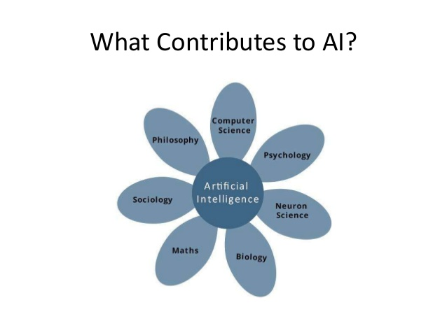

Fig1.1 What contributes to AI [1]

The various disciplines such as biology, computer science, mathematics and engineering, contribute to the constituents of artificial intelligence. Its major thrust although is in the development of machine intelligence, computers which function by the association and help of human intelligence and focusing on problem solving and reasoning and the most important part- learning.

The era of artificial intelligence-

A figment of our imagination, of what was once used to be something to ponder upon in the distant future, a fictional work of some science fiction writer, from being a momentarily thought of a fickle future to being the most sought out field in the world, artificial intelligence is taking root and it is now an integral part of our everyday lives.

Although we are still a few years behind before we start to have robots answering to our problems, at our beck and call but artificial intelligence already has a profound meaning and an unmatchable impact in one way or other, making its presence illuminate in a manner that is subtle but bold. From weather forecasts, filtering emails, removing spams to Google’s search predictions and recognition features for example- Siri, these technologies have one thing in particular- machine learning algorithms. These algorithms enable them to react, act and respond all in the present real time. Yes, there will be lingering doubts and there will be many failures and growing pains and losses as the artificial intelligence technology evolves but the effect and impact it is going to have on this society in the terms of accuracy and efficiency will be immeasurable and world changing.

The very pledge and commitment of this technology is its promising ability to learn continuously from the data it collects. The more data to learn from, to analyse, with the help from algorithms, which are fabricated very carefully, the better the system becomes at making decisions and predictions. Take for example- it’s the weekend and you’re not sure what movie you should watch, but there is nothing to worry about, Netflix will definitely have suggestions for you based on your choices or your previous watch history. Or if you don’t want to drive on a particular day to your office, well you have Google, currently working on a solution for this dilemma too, as it has a driverless prototype car stacking up the kilometres.

A BOON OR A BANE?

It is not tough to admit that artificial intelligence is transforming almost everything we know around us, the nature of which is connected to our human life, like take the fields of economy, employment growth, warfare, means of communication, our security, ethics, medicine, concerns of privacy, business and technology is ever evolving.

But, evolution on a long-term basis is yet to be seen, we don’t know where it will take us, will it be leading humanity towards a place where it can make this planet prosperous and on the verge of a perfect habitat or a place full of doom and disaster. Although every technology has its limitations and disadvantages but for it to survive in the market, the advantages should always outweigh the negatives impacts it might have or its disadvantages. In the case of AI, it is yet to be seen, the negative impacts and positive impacts are always going to be there but the positive impacts do seem to be outweighing for now. If we take a look around us, smart homes, smart cars, smart healthcare are all sought out by us, industry 4.0 is much appreciated but on the other hand we often see protests against embracing the change and the government in relation with unemployment and security concern and privacy invasion, taxes, etc.

Also as the development is speeding up of the technology using artificial intelligence, robots are being created more and automatic systems are being generated which is obviously replacing the human labour. In the long term, results will be more interesting, AI can be used in as an opportunity, we shall not forget that while innovations and new technologies at a workplace do result in job displacement, but eventually it will lead to the creation of new opportunities and industries, there are never any real boundaries than those we decide to draw for us.

If we take Flipkart for example, it was a disruptive, questionable innovation during its launch period. Because of it today a local seller or manufacturer from any state, city, district can sell his/her product throughout the country, enhancing its reach and target of customers. Not limited to that, it has employed, a large number of the population, mostly the youth of the country, as delivery executives. Hence proving a crucial point that innovation can help create new jobs and improve the ranges of an existing number of small businesses. Envisaging can be difficult but according to a report by the World Economic Forum, 58,000,00 more jobs obviously owing to the implementation of artificial intelligence, are expected in 2022, created by the end of that year.

How it can change the world we know-

THE BUSINESS EFFECT OF ARTIFICIAL INTELLIGENCE-

Unarguably Artificial Intelligence has had the most amazing and greater impact in the beginning of the 21st century than anywhere else. The technologies developed using it are having a breakthrough increase in the productivity using machine- learning and this kind of growth was never seen before. We are now familiar with trend predictions, management in workflow tools and even the way the brands have been purchasing and flaunting their advertisements. The way business was done before is changing and all thanks to AI. An awestruck but not really surprising moment came when a venture capital firm from Japan recently became the very first business company in time to select an Artificial Intelligence, member from its board, for its outstanding ability to predict the trends in the market faster than any human.

AI IN HEALTHCARE-

Empowered by artificial intelligence, many medical technologies are making a rapid progress and are evolving day after day into solutions which could be used for medical treatment and clinical diagnostic practices. It has a stronger impact in healthcare innovations because of its expertise in analysing huge amounts of data which leads to a personalized level of accurate treatment and quick diagnosis which can help prevent the advancement of the medical conditions. Radiology being the branch which has been the most welcoming to the use of artificial intelligence, being upfront for this new technology.

Artificial Intelligence: Agriculture-

Here’s a pretty scary fact the world we know and love will need to produce 50 percent more than what it usually does, of food products by 2050 because we’re literally eating up and destroying (by not being careful of our resource and by not trying to preserve our environment) everything! The only way this can be made possible is if we use our resources with more care. But a good news is that, AI can help farmers get more from the land while using resources more sustainably. Worrying factors such as climate change, population growth, and food security have us all concerned and have pushed the industry into seeking more of new technologies and innovative methodologies to improve crop yield.

Organizations are using automation and robotics to help farmers find more reliable ways to ensure the protection of their crops from pests and weed.



Fig1.2 The various spectrums of AI[2]

But let’s not expect a takeover by machines and live in the fear of privacy invasion. Although it is easy to self-improvise, the machines lack intuition. Gut instincts can never be replaced by codes and algorithms, therefore humans are and always will be an important part of the greater good and an exclusive piece of the spectrum. The best move forward is for both the machine learning technologies and humans to work alongside and live in harmony, leaning on each other and working on pros and cons by sharing their strengths.

**Literature Review-**

1. The paper “Artificial neural networks in mammography: application to decision making in the diagnosis of Breast Cancer”, by Y Wu, M L Giger, K Doi, C J Vyborny, R A Schmidt, C E Metz, 1993, Radiology, investigated the potential usage of artificial neural networks as a decision making aid to all radiologists in the study of the mammographic data. In conclusion, they found out that these networks do provide a vital useful tool in the mammographic decisive task of figuring out the difference between benign and malignant lesions.
2. In “Fundamentals Of Artificial Neural Networks”, by Mohamad H. Hassoun,1995, MIT Press, investigates numerous illustrated examples and computer based analytical problems though it provides the first systematic account of artificial neural networks paradigms and identify many crucial fundamental concepts and methods conveying most of the present theory and practices being done by the researchers.
3. “Feature Extraction by Genetic Algorithms for Neural Networks in Breast Cancer Classification”, authored by B.G. Kermani, 1995, IEEE, provides another usage of augmenting neural network training and in today’s world in which computerized identification and recognition is expanding by leaps and bounds its horizons in the area of medicine, breast cancer detection is gathering a wide attention this paper provides yet another crucial technique using a hybrid genetic algorithm and a neural network for the purpose of classification.
4. The paper “Evolving Artificial Neural Networks” by Xin Yao,1999, IEEE, showcases various combinations of artificial neural networks and evolutionary algorithms and usage of EAs to evolve neural networks connections and weights, architecture, learning rules and features of input. A lot of literature reviews have stated that these combinations can lead towards a significant and better intelligent system that relies either on both or alone.
5. “Neural Networks for Breast Cancer diagnosis”, Yong Liu, 1999, IEEE, states the basic idea behind the usage of a collection of neural networks rather than a single one is a divide and conquer strategy. The algorithm of negative correlation training had attempted to dispose a problem by decomposing automatically and then solving it.
6. “Artificial Neural Networks Applied to Survival Prediction in Breast Cancer” by M. Lundin, H.B. Burke, J. Lundin in 1999, oncology, the evaluation of the accuracy of a neural network in predicting survival from breast cancer is done. This paper clearly provides evidence that there is a need of a new prognostic system in cancer that can give a large number of factors for prognosis. An impressive idea was executed by dividing a series of 951 patients suffering from breast cancer into a training set of 651 patients and 300 patients of validation set. Total of eight variables were used as input and the evaluation was done to get tumour size, tumour necrosis and age, etc.
7. “Artificial neural networks: fundamentals, computing, design, and application” by I.A Basheer and M. Hajmeer, 2000 in Journal Of Microbiological Methods, gives us a generalized methodology for a successfully developed artificial neural network’s project including the correct use of concepts, designs, and the implementation is also described in great detail. Artificial neural networks are analysed and compared with various expert systems and their usage and disadvantages and boundaries are also shown.
8. “An evolutionary artificial neural networks approach for breast cancer diagnosis”, by Hussein A. Abbass, 2002, Elsevier presents an evolutionary approach in artificial neural networks known as EANN, it is based on the pareto- differential evolution algorithm known as PDE, consisted with local search for breast cancer detection.

It was named MPANN, memetic pareto artificial neural network. Artificial neural networks are said to be used in diagnosis of breast cancer which helps improve and enlarge the scope of the work of various medical researchers and practitioners.

1. “A validated gene expression profile for detecting clinical outcome in breast cancer using artificial neural networks” authored by L. J. Lancashire, D. G. Powe, E. Rakha, C. Lemetre, B. Weigelt, 2009, Springer, enlightens us on the gene expression microarrays which allows a high throughput analysis of a large numbers of gene transcripts. This is a widely used technology and has been applied to the classification of cancer patients both biologically and molecularly.
2. The paper “Computer aided breast cancer analysis and detection using statistical features and neural networks” compiled by the authors Roopa Ashok Thorat and Ruchira Ajay Jadhav,2009, ACM, takes up mammography, which is known as the single most constructive way for breast cancer screening. They have used a feature extraction method which is statistical with the help of an analysis through a sliding window analysis for detecting small masses in the mammograms for effectively finding out the exact tumour position.
3. “Artificial Neural Networks”, by B. YEGNANARAYANA, 2009, PHI Learning, gives a genius analysis of many topics and subtopics under the basics of artificial neural networks and dividing them into small functional units like pattern recognition, feedforward and feedback neural networks, and also provided architectures and building blocks for complex tasks of recognition of pattern. Although throughout the paper focuses mainly on pattern recognition tasks it also gives us a look of real-world applications which does ensure a practical notion to the discussion.
4. The paper “A Survey on Neural Network Techniques for Classification of Breast Cancer Data”, by Shweta Saxena, Kavita Burse, 2012, IJEAT, studies a number of techniques used for the detection and diagnosis of breast cancer using artificial neural networks. Different algorithms and methods are suggested and explored. The accuracies of these methods are compared to predict which method would work best. Some methods used are- MLP, Fuzzy-neuro-system, GRNN, etc.
5. “Breast Cancer Detection Using Cartesian Genetic Programming evolved Artificial Neural Networks” by Julian F. Miller, Arbab Masood Ahmad, Gul Muhammad Khan, S.Ali Mahmud, 2012, ACM, in this paper a fast learning artificial neural network is studied called the CGPANN, to provide accurate diagnosis and produce an optimal result using the neural network model for breast cancer. It is noted that although using the same data sets as its competitive other methodologies, this system has a better classification accuracy and this also gives less errors.
6. “Principles of Artificial Neural Networks”, by Daniel Graupe, 2013, World Scientific, is a unique paper which states 18 complete studies of numerous neural network applications in a varying range of fields like cell-shape classifications, micro trading in finance and to recognition of constellations, also providing us with their codes respectively.
7. In “Artificial Neural Networks- architectures and applications”, Kenji Suzuki,2013, Books On Demand, provides recent discoveries and advances of various new methodologies and applications and architectures of neural networks. It is divided in two parts- first one deals with design, optimization and analysis of the neural networks and their architectures. The second part deals with stating its applications in different fields of study and research like medical, industrial, physics, etc.
8. “Fast Modular Artificial Neural Network for the Classification of Breast Cancer Data” by Doreswamy and M Umme Salma, 2015,ACM, interestingly comes up with an idea of using FM-ANN, a fast modular artificial neural network. They came to produce the highest classification results in comparison of other types of networks used before. A modular neural network is actually formed using four types of different feed forward neural networks and the selected input which is refined are sent to each of the four where they perform their respective tasks and later the final result is inculcated using their sum.
9. “Evolutionary Neural Networks versus Adaptive Resonance Theory Net for Breast Cancer Diagnosis”, a paper written by Tanistha Nayak, Tirtharaj Dash, D. Chandrasekhar Rao and Prabhat K. Sahu, 2016,ACM, considers the algorithms Biogeography based Optimization and Particle Swarm Optimiazation used in this work as evolutionary algorithms, which are used to get the best form of behaviour which is adaptive nature of the MLP model from the various range of diversified inputs. The resulting models are named as BBOMLP and PSOMLP, which is analysed and compared with the Wisconsin Breast Cancer dataset. The result is such that the unsupervised creation provided a better performance that the supervised models which were implemented.
10. “Breast Cancer Detection using Artificial Neural Networks”, Nadeem Tariq, 2017, Journal of Molecular Biomarkers & Diagnosis, in this paper overall research is of 4 stages, quite simply explained, first stage is of image acquisition, second stage is the extraction from mammograms of features, selection of features which are more optimal and classifier to determine the correct section of the mammogram and its class. A database has also been taken.
11. In this paper “Normalized Neural Networks for Breast Cancer Classification” by Emina Alickovic and Abdulhamit Subas,2019, Springer, the authors develop a model to diagnose breast cancer with high accuracy. They use a Normalised multi-layer perceptron Neural Network. The accuracy is achieved up to 99.27% which is remarkable considering the previous researches where artificial neural networks were used.
12. “Prediction of Breast Cancer Diagnosis by Blood Biomarkers Using Artificial Neural Networks” by Carlos Castro, Rubén Castañeda, Eunice Vargas, Dora-Luz Flores and Balam Benítez-MataEmail,2019, Springer, uses the algorithms to train the artificial neural network models -Scaled Conjugate Gradient, Resilient Backpropagation and Conjugate Gradient Backpropagation with Powell Beale Restarts. The algorithms results were compared with the original works as well as other authors using the same dataset for classification task, a better classification was accomplished.

**Artificial Neural Networks- An Extension Of Artificial Intelligence-**

First let us understand the concept of Neural Networks-

A Neural Network is a series of various algorithms that attempt to find a hidden, underlying relationship through a process that resembles the manner the human brain applies in a set of given data. A system of neurons, it can be artificial or completely organic is hence said to be referred as neural networks according to this process. Mainly, its capability to adapt when the inputs given keep on changing and even then the network can generate the best result which could be achieved in such a case without needing for the output criteria to be redesigned. It has its roots in Artificial Intelligence. And it is gaining popularity in the development of new technologies in various fields.

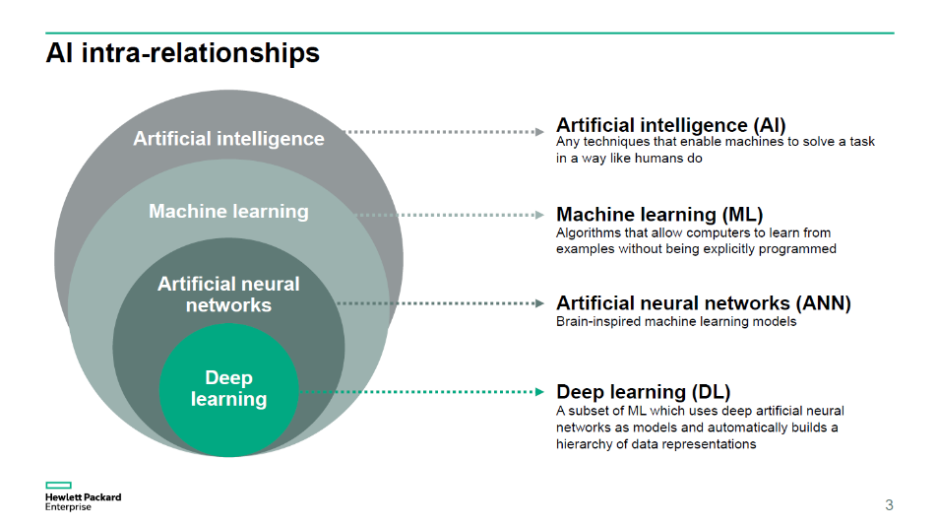

Fig1.3 The relationship of AI and its spectrums [3]

**Basics of neural networks-**

A neural network operates in the same manner the human brain’s neural network works. A neuron is a mathematical function in a neural network which can collect and classify the data according to a specified construction which is required. It carries a very strong resemblance to statistical procedures. For example- curve fitting and regression analysis. Made up of layers of interconnected nodes, a neural network contains perceptron (each node is a perceptron) and it feeds the signal that is generated by a multiple linear regression. The signal is fed into an activation function, which can be nonlinear. A perceptron is hence similar to a multiple linear regression.

In an MLP (multi-layered perceptron), these perceptrons are such designed to be arranged in interconnected levels or layers. The input layer has a task of collecting input patterns. The output signals are mapped by input patterns and the output layer is comprised of classifications or output signals. For example, the patterns may be comprised of a list of quantities about a security for technical indicators. The outputs here could be “sell” or “hold” or “buy.” Hidden layers tunes the inputs until the error margin is extremely low or minimal. Even it is wondered that these layers have extrapolated many silent features into input data that could be used to predict something related to the output data. This is the description of feature extraction. To accomplish a technique similar to statistical approaches. For example, principal component analysis.

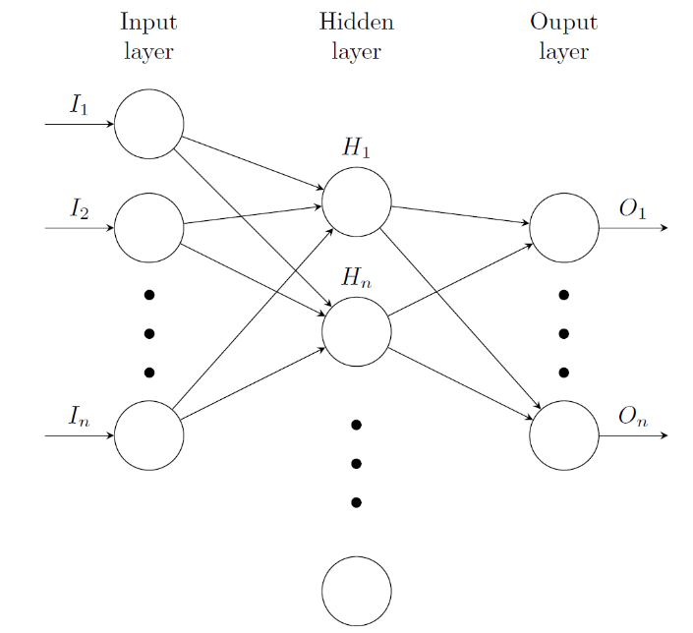

Figure1.4 A basic neural network [4]

The key takeaway is that a neural network is a number of algorithms in a series which can imitate the operations of a human brain to recognize the patterns between large quantities of data. A simple neural network is shown in the figure given above.

**Artificial Neural Networks-**  A part of a computer system which is used to simulate the same way to analyse and process information, the human brain does the task. It has the ability to solve problems that are deemed impossible or certainly very difficult by the standards of human statistics and thus it is the foundation of artificial intelligence. The more the data becomes available, the better results are produced by these artificial neural networks because they have self-learning capabilities enabling them to perform these tasks.

* An artificial neural network is that component of AI that is supposed to simulate how a human brain basically functions.
* It consists of inputs and outputs, of processing units, which make up the artificial neural networks. It learns from the inputs about how to produce the perfect required output, which is desired.
* The set of learning rules are called backpropagation, which are used to guide the ANN.
* The practical applications of artificial neural networks surpass far and wide, comprised of medicine, education, business and personal communication.

**Understanding An Artificial Neural Network-**

Built like a human brain, neurons with nodes interconnected like a web, the artificial neural networks are not that difficult to understand. The human brain, which we want to simulate here, has hundreds of billions of cells which are known as the neurons. Each neuron is again consisting of a cell body. The cell body has the task of processing information. It does so by moving the given information towards the brain in case of inputs and away from the brain in case of outputs.

An artificial neural network has hundreds if not thousands of neurons which are artificial known to us as processing units. They are interconnected by nodes and made up of units of input and output. Various assemblies of information are received by the input unit based on an internal system of weighting. The neural network then makes an attempt to learn everything about the information so that it can give one report of output. Backpropagation are a set of learning rules which are used by artificial neural networks, so that they can produce a perfect output result, just the way humans need certain rules to follow or guidelines to generate the results which are required. Backward propagation of error is known as backpropagation in short.

Initially an artificial neural network has to undergo a training phase. To learn how to recognize patterns occurring in data, whether visually or in the form of text. This is a supervised phase, and during this phase the neural network makes a comparison between its output which it has actually produced with what it is meant to produce- the desired outcome. Backpropagation is used to adjust the difference between both the outputs. Thus implying that the network works backwards. As it goes from the output unit to the input units so that the differences between the actual output and the desired output results in the lowest error that can be made possible. This is done by adjusting the weight of its connections between both the units until the task described above is accomplished.

During these phases of training and supervision, the network is taught how to look for what its perfect desired output should be and the binary numbers are used to answer the questions with the type of Yes/No. For example lets take the case of a bank that wants to detect frauds that are done using credit card on time. It may have 4 input units fed with these questions-

1. Is the transaction being done from a different country, rather than the user’s country where he resides?
2. Are the websites where the card is being used are related or in association with the companies on the watch list of the bank or the national security?
3. Is the transaction amount greater than 50,000?
4. Do the names match on the card and the transaction receipts?

Since the bank wants the detection of the fraud responses to be – YES, YES, YES AND NO. That is 1, 1, 1, 0 in the binary format, if the output is- 1, 0, 1, 0 the outputs are adjusted such that the desired outputs are delivered. So, after training the computer system can alert the bank if a fraud is being committed. Saving a lot of money.

Artificial neural networks are essentially making a path for the development of technologies that could be life changing and eligible to be used in all the sectors of the economy. It has many practical applications for the world. The AI platforms that are built on these networks although are changing the traditional manners of doing tasks, like from translation of web pages into the required language by the user to having a virtual assistant doing things for us when asked to order food online to advising on how to solve problems using chatbots, these are basically simplifying our transactions and are rendering services accessible to everyone on the internet at negligible prices. These networks have been used in operations around almost all the areas of the world. In this report we’ll see how it helps in the medical field mostly in detection of breast cancer and its applications in the diagnosis and suggesting an accurate treatment method.

**A Brief History Of Artificial Intelligence and Artificial Neural Networks-**

Let us go back to the previous time of Milat. To be informed regarding the history behind the origins of artificial intelligence. The era of the Ancient Greek, has been proven to be the time around when various ideas have been carried out, ideas about robots and intelligence, mainly humanoid robots. Daedelus, is said to have ruled this mythology. A wind of the rumour was spread around the world that he was first one who tried to create artificial humans. The artificial intelligence of modern times began to be noticed in the history, with the sight of defining the human thought, by a philosopher’s order.

The year of 1884 is said to be very important for AI. On this date, Charles Babbage, did work on a mechanical system, a machine, which would showcase an intelligent behaviour. However, he was not satisfied with his work and he ruled out the possibility that his machines could behave in the same way human intelligence could do, he had his work suspended. In the year of 1950, the idea that computers could play chess was introduced. Claude Shannon was the one who introduced this idea. The progress on artificial intelligence was made slowly, till the early 60s.

Now officially the introduction of artificial intelligence dates back to the year 1956 in history. In 1956, at the Dartmouth College, a conference session was held for the first time regarding artificial intelligence. The first applications of AI were launched during this period. These were based on chess games. And logical theorems. The programs and applications produced and developed during this era were distinguished with those used in the intelligence tests like geometric forms which lead to the idea that the creation of intelligent computers was not impossible.

In his book “Stormed Search For AI”, Marvin Minsky stated that all the problems regarding the modelling of an AI would be solved within a generation.

**Milestones of AI history-**

To find out whether a machine is intelligent or not, a test was created in the year 1950 by Alan Turing. It showcases the intelligence being given to the machine, to computers. The intelligence level of the machines who passed the test at that time was considered to be enough, adequate. A functional programming language called list processing language, in short, LISP, was created and introduced to the world in 1957 by John McCarthy and it was developed for AI. Considered to be one of the oldest and powerful languages, this allowed the user to create rather flexible programs. These programs represented basic operations with the help of list structure. Then between the years 1965 and 1970, a very dark period was seen for the artificial intelligence. The developments were minimal and could not be tested. It was considered a dark period because of the hasty and optimistic beliefs of the people that their unrealistic expectations, which only occurred because they thought that it would take a snap of their fingers to create and uncover machines with intelligence parallel to human intelligence led to failure because they could not create intelligent machines by just uploading a few data and writing some codes. Although artificial intelligence did gain some momentum during 1970-1975 and it was all thanks to the victory gained in artificial intelligence that was developed and that too on fields like diagnosis of a disease accurately which also led to the establishment and foundation of the artificial intelligence of the modern world.

1975-1980, it was a period where it was discovered that other fields of science like psychology could be involved with AI. And after that it was considered for much larger projects and practical applications. The next thing we knew, it was adapted for finding the solutions for the situations and problems of real life, artificial intelligence had skyrocketed. And then although the needs of people where already satisfied by using traditional methods, making use of AI in these cases resulted in reaching a massive length owing to the economical tools and software.

**The Origins Of Artificial Neural Networks-**

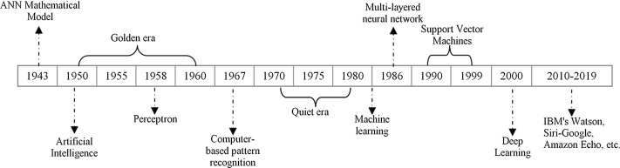

Fig 1.5 A timeline for ANNs [6]

It is of no doubt that a traditional digital computer does its tasks very well. It does every single task as we say and how we say and it is quite fast. Unfortunately, however, it is unable to help us when we ourselves do not fully understand the problem we are searching a solution for and for the worst part the noisy and incomplete data, which is literally sometimes the only form of data which is frequently available in the real world, are not dealt well using the standard algorithms. The only solution is to use an Artificial Neural Network for this because it is a system which does not require outside help, it can learn on its own. The first ANN, invented by Frank Rosenblatt in the year of 1958, who was a psychologist was known to the world as Perceptron. Its intended use was to create a model on how the visual data is recognized by human brain and how our brains learn to recognize the objects around us. After that more and more researchers submitted themselves to this evolutionary field and they used similar artificial neural network models to study the human brain and simulate its cognition.

The realization that apart from giving valuable knowledge about how the human brain functions, the artificial neural networks were useful on their own and their application could bring about a revolution, struck eventually.

Their applications like pattern-recognition, learning techniques solved many problems that were rendered impossible or rather difficult by the standard, statistical computer models. And by the end of the 1980s, artificial neural networks were used by many recognized institutes of the real world in variety of fields. Though known as artificial neural networks, they are often referred by the world as neural networks simply, but there’s a difference as that title belongs more accurately to the biological brains on which we based the original models of ANNs.

Let us look at a timeline of artificial neural networks, it might look like a roller-coaster ride. There are many certain amount of times where it was at the height of popularity and periods of darkness where it just wasn’t in the picture, i.e. down. However now its been a while since its resurrection and it has never seen a better time.

Let’s name these times as continuation and excursion (instead of progression and digression)-

• continuation during the years of 1943-1960 we got to see

– The very first and foremost mathematical system or model which was developed of neurons

∗ Pitts & McCulloch (in the year of 1943)

– The step forward, the beginning of The Artificial Neural Networks through

– Perceptron, Rosenblatt (in the year of 1958)

∗ A single neuron for categorizing or classifying.

∗ Learning rules and the convergence theorem of perceptron.

• The years of 1960-1980 saw excursion

– Perceptron, which was the beginning of the neural networks, could not learn the XOR function.

–To train an MLP was stated to be an impossible task.

– 1963 saw Backpropagation emerge though it didn’t get the required attention.

• Continuation in the 80s saw-

– 1986 the year of the reinvention, Backpropagation being resurrected.

∗ Learning representations using backpropagation errors.

– The applications were successful in- Character recognition, autonomous cars, and many more. But there were lingering doubts and suspicions in

∗ Overfitting? The Network structure? What was the neuron number? What was the Layer number? Bad local minimum points? When to stop training the system?

– Hopfield nets (1982), Boltzmann machines were introduced.

• 1993 again brought upon the excursion period-

– Support Vector Machine (SVM) is developed but it was a shallow structure.

– Graphical models gained popularity.

– The massive success of SVM and graphical models were noted and they almost wiped out the research on the artificial neural networks.

– Training of deeper networks was going nowhere, constantly showing zero results,

– A saving grace came in the form of Yann LeCun, a French computer scientist, who developed in the year of 1998 -the deep convolutional neural networks (CNNs). However, a discriminative model.

• Continuation (2006-)

Deep learning is a rebranding, a new life for the lost roots of ANN research.

– Deep Belief Networks (DBN) was developed with the following-

∗ A fast learning algorithm by Geoffrey Hinton. Neural Computation.

∗ It had a graphical model, generative.

∗ Restrictive Boltzmann machines, were the base of its creation.

∗ Best part was that it could be trained efficiently.

– Deep Autoencoder based networks-

∗ Greedy Layer-Smart Training of Deep Networks.

– Convolutional neural networks, CNNs were running on advancement of computing power, GPUs.

∗ Great success for the networks due to the enormous usage of GPUs.

∗ AlexNet was made and introduced to the world by Krizhevsky in 2012.

For the conclusion, before, the popularity of ANNs saw a downfall because of new inventions and low popularity, sometimes. But, recently since the development of the GPUs, big data availability and new training techniques for deep networks with massive datasets, the ANNs have been rejuvenated and the deep learning research have redeemed their popularity.

**Advantages of ANNs-**

Let us take a look at some the advantages of using an artificial neural network and why do researchers prefer it over other systems-

* Firstly, the number one advantage is that any kind of information is stored on the entire network. Even if a few parts of the information do get displaced or lost does not stop the network from doing its job. For example- information like traditional programming.
* It can do its job with half or incomplete knowledge. After we train the neural network, it gains an ability, to produce the results even in situations where it has not been provided the complete set of information regarding the problem. Now, it does however depend on what type of information is missing, did it hold a key part to produce the perfect output.
* Fault tolerance, for example- if one or more cells are compromised, of the artificial neural network, then this corruption does not prevent the network from giving us the output.
* It has a distributed memory. The network can produce a false result sometimes because for the network to work, it has to be able to learn and in order for that, it is deemed important that the examples we are using to teach it are determined and they are in accordance with the required output. The success in this case is directly linked to the examples we selected and if we fail in showing the network all the selected incidents then it can produce a wrong result.
* Over time, a neural network will eventually slow down. It can undergo relative degradation, but this network problem immediately does not dissolve, does not corrode, this is called Gradual Corruption.
* It has the capability and strength to do more than a single job at the same instance of time, this property of the network is known as parallel processing which is its most illustrious advantage.
* They learn through events and base their decisions accordingly on similar instances. Therefore, it has Machine learning ability.

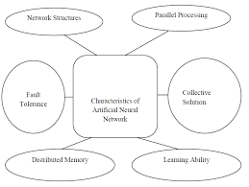

Fig1.6 The characteristics of artificial neural networks [5]

**Disadvantages-**

* Parallel processing potential processors are required by the networks. According to their designs. Because of this situation, there is a disadvantage of hardware dependence.
* The most important disadvantage though is the unexplainable behaviour of the ANNs. The trust on the system gets diminished when it refuses to give a reason when an ANN provides a delving solution. We do not get a single clue as to how and why the solution was created and produced to us.
* There aren’t any particular rules to determine the proper network structure, it can only be achieved through the experiments and experience.
* ANNs can only understand and work when they are given information in the numerical format, thus creating a struggle of providing a problem to it. Problems have to undergo translations. The performance of the artificial neural networks depends now on the user’s attempts. Because the display process which is to be determined directly influences how the network will respond.
* Network duration is undetermined. Because the network is lowered to a error of a particular value when the training gets completed depending upon the sample provided, that does not ensure that the result is the perfect output.

**Applications of Artificial Neural Networks-**

* It has applications used in solar energy. For the development and construction of plant which could create solar steam.
* They have found usefulness in the field of system identification. They could do complex mapping in the modelling of any system.
* They have a plethora of applications in robotics and pattern identifications. In medicine, forecasting etc.
* They could deal with non-linear problems. They can work with noisy and incomplete data.
* They can be used in ac systems, solar radiation control, control of power generating systems, refrigeration, etc.

**Some limitations-**

1. It is a not a system which can solve our daily life problems.
2. The quality of the output could be undeterminable.
3. There is a massive computational load.
4. They are secretive sometimes about how they solve problems.
5. No structured methodology is present.

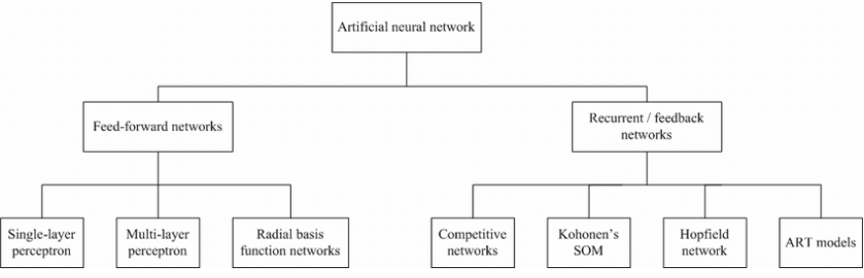

Fig 1.7- The classification of artificial neural networks [9]

TYPES OF ANNs-

Its time to dive deeper and acknowledge the impact the artificial neural networks are making in its quest of technology world domination.

* Feedforward- It is the simplest form of an ANN. The information goes through a number of computational units called input nodes till it reaches a node called the output node. The data, basically goes into a single direction, this network does not create a loop so that the network can learn, from an input computational node to the exit node, it does not have any feedback methods. The output from every layer of neurons is not fed back to that neuron so that it could learn. Example- it has applications in face recognition and computer vision.
* RBFNN- A radial basis function neural network is comprised of a minimum of 3 layers called input, hidden and output layers. The hidden layer is only one in comparison to multiple hidden layers found in other networks and its typical use is to reduce data redundancy. Learning is done very fast here. This network finds its applications in restoration systems with complex power.
* RNN- A recurrent neural network is like feedforward network, the only difference being that it saves the result of a particular layer and later uses it to feed it back as an input. This way from any chosen layer, many outcomes could be predicted as possible. Like for example if the second layer has an output generated and it saves it to feed back as input, the next layers will then start the process of RNN. The memory would be retained. Therefore, the system would not make wrong decisions as it will learn from previous mistakes and improve the outcomes. Their application is seen in text-to-speech. Predicting on what to say next after learning the initial input context.
* MLP- Multilayer Perceptron. Used mainly in speech recognition. It has three or more than three layers to organize data which is unable to separate in a linear fashion. It is connected full, every node in connected to the next one succeeding it in the next layer, within a layer.
* A CNN, convolutional neural network, are used mainly for accurate face detection. Even if the provided image is not of a good resolution, this network does its work. Making work of a different kind of MLPs, these have several layers which have the ability to get interconnected fully. Primarily used to decipher a particular part of a given input, their purpose solely is to give accurate output.

Artificial Neural Networks in MEDICINE-

With the advancement of new technologies, AI is now the talk of the town in the field of medicine and research and the interest of various developers and clinicians have been drawn towards it. One such evolutionary branch of Artificial Intelligence are Artificial neural networks, without a doubt. Nowadays also a lot of research is being done extensively on this topic.

Artificial Neural Networks are becoming a powerful weapon used by the clinicians to analyse, make a model of and decode complex information of medical data across a massive length of medical approaches. Its task is mostly to perform classification that means it has to put the patients in one of the many small classes based on the features which are studied and measured.

Now let us start with our subtopic.

**BREAST CANCER—PROLOGUE**

**WHAT IS BREAST CANCER?**



Fig1.8 The symbolization [10]

When abnormal cells in our body grow disorderly and out of control, which is what happens in all the forms of cancer, the situation is diagnosed as breast cancer and the cancer is said to be made up of these abnormalities. The cells are free to situate themselves in any part of our body where they couldn’t be easily found by circulating. In this situation, the cancer is known as metastatic. Breast cancer starts in a small area in our glands, mainly lobular carcinoma- responsible to produce milk or in the ducts, ductal carcinoma, responsible for moving the milk to the nipple, at first they begin in the confined areas of these glands or ducts and then they can grow massively in the breast area and start spreading throughout like from our bloodstreams to other nearby organs and more, or to lymph nodes via channels. The skin tissue or the chest wall are invaded when the cancer grows, the growth depends on the type of the cancer, different types take different amount of time to spread, some might take years and some might do so in quick succession from tissue to organs.

**Who gets the cancer?**

Men too get this type of cancer but the cases are accounted to not more than 1% of all the breast cancer cases even less than that in actuality. Among the female population, it is the second most common type of cancer after skin cancer, it is also the second ranked cancer which results in death after lung cancer in women. Researchers say that one out of eight women develop this cancer in a lifetime, on an average scale. Around 2/3 of the female population diagnosed with breast cancer are above the age of 55, rest are between 30-55.

There is nothing to worry about if it is detected early, because it becomes likely to be very treatable. If the cancer hasn’t spread outside of the breast, then it can be successfully removed before it reaches to other vital organs. This form of cancer is called localized cancer. It is said that a woman who is detected of having this cancer has a chance of 99% to live, if she has localized cancer. At least till 5 years since the diagnosis.

But when the cancer starts spreading, extensive care and treatment is required, and the disease is put under its spell for years. Although through new and improved detection and screening methodologies, treatment options get a wider range and it can result in the recovery of about eight out of ten women and they can survive for at least 9-10 years after the first proper diagnosis.

**Symptoms-**

* Lump, a thickened portion in your breast or around that area, or in your underarms which stays even after your menstruation is over.
* The lump could be a mass as small as a pea which could be the cancer.
* Difference in the shape, size or curve of the breast. Or changes in the shape of the nipple or the position.
* A bloody or clear discharge around the breast.
* Dimpled, scaly, inflamed skin, or puckered skin on the breast or nipple. The skin could have a minute difference or it could feel different.
* Redness of the skin.
* A hard mass maybe marble sized and stony under the skin.
* Any part of skin which is different from any other part on the breast.

**Types of Breast Cancer-**

Some of the most common types are-

* In situ- A type of cancer which has not moved forward from where it had begun, originated mainly from the duct or lobule. DCIS (ductal carcinoma in situ)- the cancer in the earliest stage, i.e., stage 0. The lump is still in the milk ducts. It is easily treatable but if not done so in time, it can become serious. LCIS (lobular carcinoma in situ)- present only in the lobules as the name suggests, which are responsible for milk production, again its not a real cancer but it does require the stand exam and regular mammograms.
* Invasive Cancers- the type of cancers which has already invaded the tissue around the breast area. It has the following types- 1. IDC- The most common form of the invasive cancers and almost 80% of these types of lumps are recognized as invasive cancers of the form infiltrating ductal carcinoma. Originating in the milk ducts. It moves into the breasts and invades through their fatty tissues. It does so by breaking the wall of the duct. 2.- ILC- so this form of invasive cancer answers for 10% of the cases, known as invasive lobular carcinoma, as its name suggests, the lump forms in the lobules. But it invades through them and spreads in other parts of the body and nearby tissues.

Subtypes of Invasive cancers-

When the tumour is growing slowly and are in the shape of a tube. These cancers are called Tubular Carcinoma. When women who have gone through menopause, are affected by cancer and the lump is like a finger, or projections of a finger-like manner, then this invasive cancer is referred to as Papillary Carcinoma, they are very rare and account for less than 1% of the cancers. If the tumour is like cells present in the saliva or salivary glands, then it is referred as Adenoid cystic carcinoma. If the tumour is like a soft, squishy mass, and resembles the medulla of your brain- then it is classified as Medullary Carcinoma. If the tumour is rare and growing very slowly, it is called as a low grade adenosquamous carcinoma. This is a type of metaplastic carcinoma. And it is often mistaken. Mucinous carcinoma- referred if the lump is surrounded by a pool of mucin, which is a part of mucus.

Less common types of breast cancer include-

1. When the cancer spreads to the brain, lungs or other body parts- Metastatic.
2. Lump caused by inflammatory cells in the skin’s lymph vessels- inflammatory.
3. Paget’s disease, Phyllodes tumours are the rare tumours which effect the areola and grow in a leaf-like form respectively.

**STAGES OF BREAST CANCER-**

1. Stage 0- the cancer is non-invasive, it is localized and does not invade other organs or tissues and shows no tendency to spread in this stage.
2. Stage I- The size of the tumour is approx. 2cm or less and again it does not show any tendency to spread yet.
3. Stage IIA- If we take underarm lymph node to be involved- then the size of the cancer is less than 2 cm and if we take it without, then the tumour is greater than 2 but smaller than 5cm.
4. Stage IIB- Here the size of the tumour if larger than 5cm, tests positive for breast cancer and without the involvement of the underarm lymph nodes. And with their involvement the tumour is greater than 2 cm but not more than 5 cm.
5. Stage IIIA- Often called locally advanced breast cancer. It is characterised as-

If the tumour is more than 5cms in size and has spread around. Mainly near the lymph nodes or the breastbone area. Or, the tumour could be of any size but the tumour has the lymph nodes that stick together or get glued towards the nearby tissues and which are cancerous in nature.

1. Stage IIIB- The cancer spreads. Mainly to the skin and chest wall and could be of any size.
2. Stage IIIC- Spread more broadly and has more lymph nodes involved, cancer could be of any size.
3. Stage IV- Again the size of the tumour could be anything, it does not matter in this stage. Bones, lungs, livers, the brain are all invaded by the cancer in this stage.

**Diagnosis**

Any doctor will diagnose the type of cancer by performing routine screening. Or when the patient herself detects the signs ang goes for a check-up.

There are numerous tests and procedures available to reach to a diagnosis. Such as-

Breast examination- to check if there are any lumps of any size, could be minute but can still be the sign of the development of cancer and other symptoms are also accounted for in this procedure. It is done by making the person sit or stand with their arms in various angles like pointing forward, or above the ears.

Imaging tests- A mammography is a type of X-ray. This procedure is done in the initial stages when the imaging tests or screening are being done to detect whether the lump is really a tumour or not. This procedure produces an image that decide whether the suspected area really has an abnormality or not, further testing is also done based on the results but the mammography is not always accurate. Ultrasound- A scan done using sound waves. It helps in clearing the suspicion between a lump, a hard mass and a cyst filled with some fluid. MRI- it is used for patients who might be having a high chance to get breast cancer. It is done by putting together various images of the area suspected of having any abnormality. It could also be performed as a follow-up after the above two methods, and it stands for magnetic resonance imaging test.

When a sample of a tissue is extracted and that tissue is analysed in a lab, then the method is known as a biopsy and it is used to prove whether cancer is present in the cells or not. And if detected, further it tells us the type of the cancer and if it is hormone sensitive or not. The size of the lump, whether it has spread or not, invaded other organs or not are all answered in the staging process and it helps in finding out the survival chances and what treatment to adopt.

There is no exact reason or cause for someone to get this cancer, but there are certain risk factors. After adolescence, a female breast constitutes of tissues which are connective, fat and many lobules which could be 1000s in number, tiny glands which are responsible for generating milk and ducts which have the responsibility to carry it. The tumour is the reason behind the multiplication of these cells which are beyond control and these cells do not die when they are supposed to after their life-cycle has been completed. The tumour then feeds off of the energy which was supposed to be used by those cells and hence they become the cause of cancer. Usually the cancer starts within the lining of the mentioned lobules and ducts, and then spreads around on the body according to their own time which is also unpredictable.

Although it is possible to prevent some of the risks which could lead a person to get any type of cancer. Let us see a few risk factors-

1. Age could be a factor as the risk of getting this cancer in women grows as they grow older. Especially after puberty. Like the probability is 0.06% for the age of 20, to develop breast cancer in the next 10 years and by the age of 65+, the probability becomes 3.84%.
2. Genetics also play a role in this case. Mutations in the genes- BRCA1 & BRCA2 which could be inherited from parents, are said to be the ones providing the highest chance of the development of tumour in women, carrying their certain mutations. Also, the TP53 gene could also be responsible. If someone within the immediate close family has a history of breast cancer then again, the chances are high of developing breast cancer.
3. If someone has recovered from the cancer previously then the chances of getting the tumour again is higher than someone who never had any history of this disease.
4. Dense breast tissues or breast lumps, which were non-cancerous before could result in cancer later on. Estrogen exposure increases the chances of getting the tumour, for example when a person starts menstruating at a young age and enters menopause earlier than the expected age, they could develop this cancer as estrogen levels are especially higher during this period.
5. High sugar intake, overweight, obesity after hitting menopause, the probability of getting this cancer is higher.
6. Alcohol consumption, Radiation exposure, hormone treatments. Could lead to the development of breast cancer.
7. Cosmetic implants.

There are many preventive measures and treatment options available and a person’s viewpoint and positive attitude also matters a lot, which would be seen more if the cancer is detected earlier and there are various treatment measures available. According to researchers, a patient diagnosed earlier at stage 0 or stage 1 and gets proper treatment accordingly has a 99% chance of recovery and they could live for at least 5 years. This life expectancy is only achieved after getting diagnosed early in comparison to those who never had cancer.

When diagnosed at stage four, the chances of survival of another five years is reduced. Around 27%.

**Breast Cancer- A Silent Killer in India?**

Let us study breast cancer in India. There is no use of denying the fact that- Breast Cancer is the most frequent type of cancer in this country, leaving behind cervical cancer a long time back. Cities of Mumbai, Kolkata, Delhi, Chennai, Ahmedabad, Bhopal, reports more than one fourth of all female cases of this disease, accounting for 25-32% of cases. Devastatingly it is also most common in thee youngsters of this country. Around 50% of all the reported cases are in the ages of 25-30. Around 70% and more cases were in the higher stages when detected and had no chances of survival and the mortality rate was through the roof. This takes us to the conclusion that the chances of survival from breast cancer in India are low because detection of the tumour takes place very late and therefore it is appropriate to call this a silent killer.

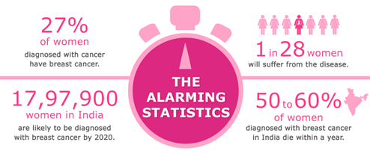

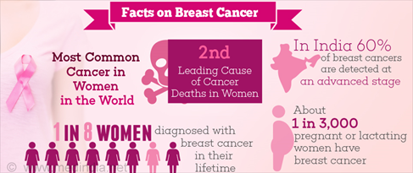

Fig 1.8.1- worrying facts [10]

**Trends of Breast Cancer in India-**

If we talk in simple words. Although it is a worldwide disease, present in all parts of the globe. But the underlying reasons of getting the cancer, features of the tumour which are in majority are uniform in every country, usually. Not neglecting the fine line that every region does have its own uniqueness for breast cancer. Saying that, the trends in India are worrying and should not be ignored.

* The reported cases of breast cancer are from the younger age groups of the country. And the incidences are increasing day by day.
* The lack of awareness, even when so many people are suffering from this disease.
* Late presentation and detection which leads to decreased survival rate from breast cancer, this is the most worrying trend of the country.
* The cancer found in the younger age groups spreads so aggressively that if not detected at an early age reaches to all the vital organs.
* Lack of screening (correct assessment of the tumour).

**The Pink Initiative-**

**AI and Breast Cancer-**

In a breakthrough with the war against this silent killer, researchers said after all their hopes got achieved through a computer algorithm which could detect breast cancer from normal routine scans with a massive accuracy than any expert technique of humans could using artificial intelligence. With more than 2 million cases reported only from last year, this common form of cancer in women can only be fought with an early diagnosis to determine the proper treatment, regular check-ups are the most vital element of this war, because they can detect the early signs of cancer even in patients with no tendency to get it. In Britain, of age groups above 50, are often recommended to get mammograms in an interval of every three years, and the results of those mammograms are looked upon by two different medical experts, which showcases the seriousness of this disease. But the studying of these results are not always accurate, there is always a place for error somewhere, and its not a secret that a small part of these scans either gives the output of false positive that is, misdiagnosis of a healthy person or false negative, that is mistaking the cancer for something else or missing it altogether as it spreads in the body. The experts of Google health have trained a model to detect the tumour from these scans using AI, by taking samples from thousands of women in the USA and UK. Those scans were already studied by the doctors but unlike in medical practises the model had no access to patient history and it could not use that to confirm or inform its detections. This led the team to conclude that their model could predict cancer from the images with the same accuracy as high-level radiologists/radiographers.

Also, this AI showed a decrease in cases where the misdiagnosis of incorrect cancer had taken place- accounting for 5.7 and 1.2 percent in the USA and UK respectively and the percentage of cases where the cancer was missed was 9.4 in USA and 2.7 in UK.

Dominic King who is the lead at Google Health in UK said that – The earliest the diagnosis, the better the survival chances. This evolutionary technology in a way gives the expert and the patient the ultimate power to obtain the best possible result they can from the diagnosis they have had.

The major techniques to focus upon are- image processing- as they occupy an important place in the detection and diagnosis of the tumour and monitoring the patients who have been already suffering from it.

Acquisition of the image, extraction of features from and, selection of more optimal features, classification to identify the appropriate class of mammogram are the basic techniques adapted.

**How AI can help with ANNs-**

The medical experts from around the world are currently performing the estimations of recovery and probability of the survival chances available from techniques which are non-numerical. The prognosis of the medical result of the patients after they will have surgery of breast cancer also plays an empirical part so that tasks could be decided beforehand for the correct treatment and diagnosis planning.

Artificial Neural Networks have been proven to be a successful tool for the study of datasets where there are complex non-linear interactions. Between the entered data which is the input and the outcome which would be the information or data we want to be predicted. Researchers say that extensive experience is required to accurately study the images of the breast and nothing is more powerful that AI because it can help find and predict the cancer with lesser recalls, finding out the cancer in early stages before it can spread throughout the body.

**Detection and Awareness-**

The Lancet Digital Health Organization published a paper which praised greatly that an algorithm that was created using AI constituted of various number of mammography, and their information on a massive scale showed a marvellous performance than any radiologist by accurately diagnosing and detecting the breast cancer present in the images. With the aid of this technology the evolutionary and significant the development of better results which have been observed in the performance of the clinicians and hence supporting the fact that the use of AI have brought a significant change for mammograms, as a diagnostic tool they have been improved a lot. Awareness about the disease is also very important and is so is self-assessment.

Using the references and data from the Mayo Clinic- One can use self-awareness techniques as- Starting with a visual examination and to look for a hard mass or lump, a small knot near underarms, which could be of any size and should not be ignored. Changes which could be noticeable by touching or through squinting your eyes in the way your breasts look or feel which consists of thickening that is different from the nearby tissue, or fullness which is visibly prominent around the other tissues. Dimples, puckers, bulges, ridges on the surrounding skin under suspicion, redness or swelling or pain around the concerned area when touched or in general or any intensity. Itchiness, sore rashes and scaly skin should not be ignored. And if there is a bloody discharge around that area then one should definitely visit a doctor.

**Statistics of breast cancer in India-**

* We already know it is the most common cancer in Indian women.
* Accounts for 25-32% of all female cancers in Indian states and cities.
* One woman is detected every 4 minutes with this tumour.
* One woman dies suffering from this disease every 13 minutes in this country.
* 70,218 women have been estimated to have died from breast cancer in 2012, in our country which is the highest count in comparison to the world in 2012.
* **Only Sixty percent** of the women who are treated for this disease survive for at least five years in India post their treatment. In comparison 89% women survive for at least five years in USA after treatment.
* 50% and more women after their diagnosis are found out to be at stage 3 or 4 and thus the chances of their survival are extremely less.
* Hence, the mortality rate is quite high because of the two reasons- lack of awareness and the late detection of the cancer due to delayed screening and no accurate diagnosis to provide a better treatment plan to the patients.

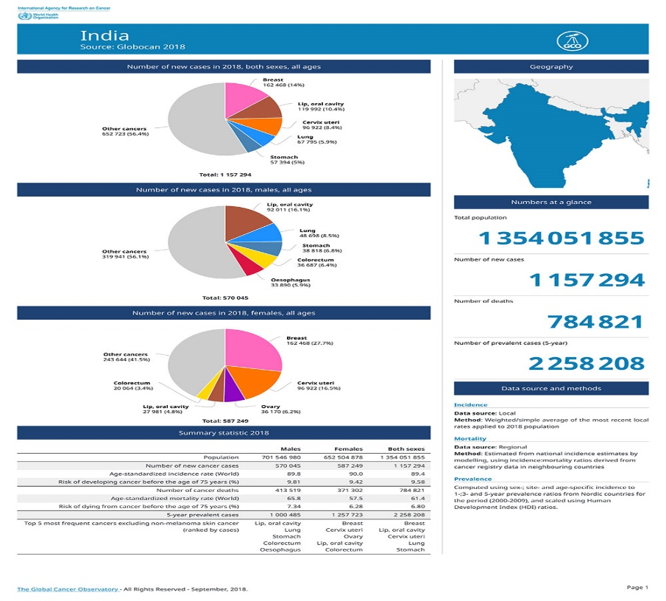

Fig 1.9 Statistics of breast cancer in India [8]

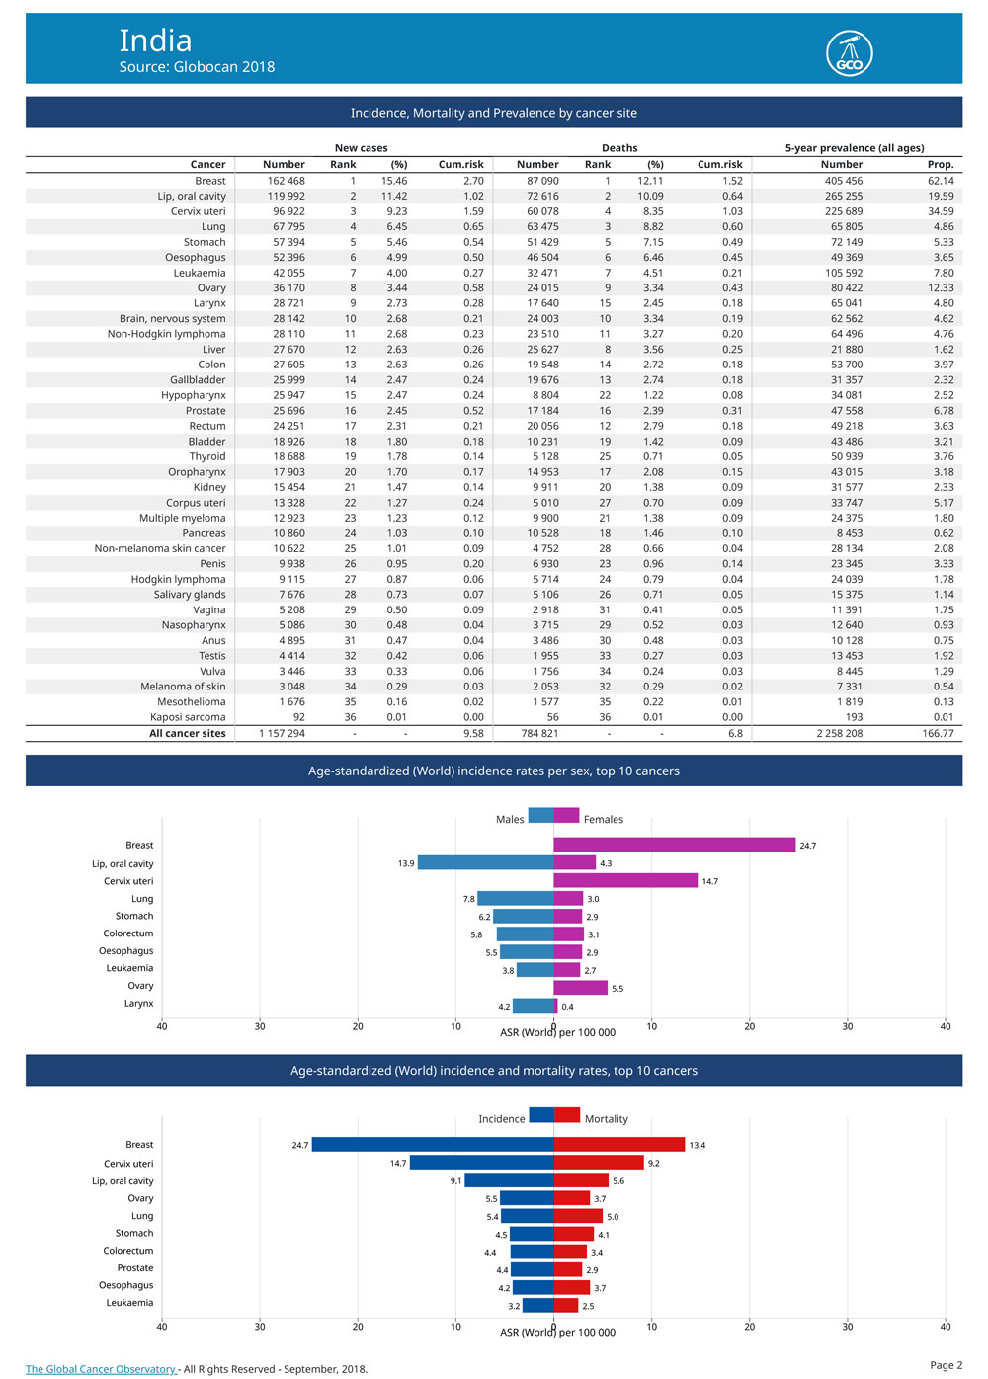

Fig 1.10 Trends of cancer in India [8]

Artificial Neural Networks- the methodology implemented using a technique of ANN on a dataset which was collected, including the results and images of the mammograms and was used retrospectively showed risk factors and medically analysed data to accurately whether an individual had breast cancer or not and what was the probability of getting the cancer.

For example- if we take evolving neural networks, for the detection of the cancer, from histologic data, the programming and adapted technique used to train the neural network would be evolutionary. Preliminary results would show here that very few neural networks could be able to outshine and show a better performance than what was already done on the same data. The results of which are very significant, speaking on statistical terms.

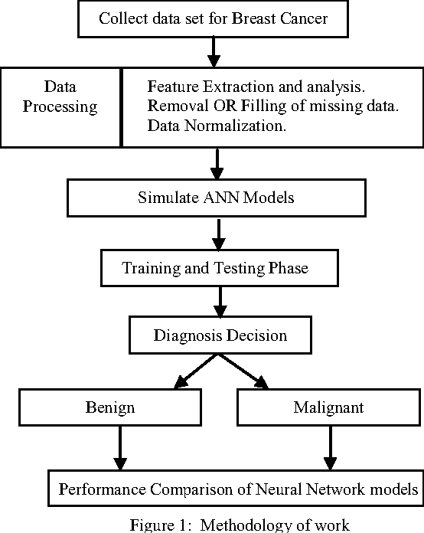

Fig 1.11- How Ann works in the detection of cancer [7]

**ARTIFICIAL NEURAL AND BREAST CANCER-**

**“SOLVING CANCER”- THE APPLICATIONS OF ARTIFICIAL NEURAL NETWORKS IN BREAST CANCER DIAGNOSIS AND DETECTION-**

**Use of ANN for breast cancer Diagnosis and Prediction and the Existing technologies-work done nationally and internationally-**

Let us examine a brief split-up of the various modes of Artificial Neural Network architectures used by the practisers and researchers in the recent times, although there is always a scope for a new technology round the corner and better performances with new ideas, the work performed have also been proven revolutionary in many cases.

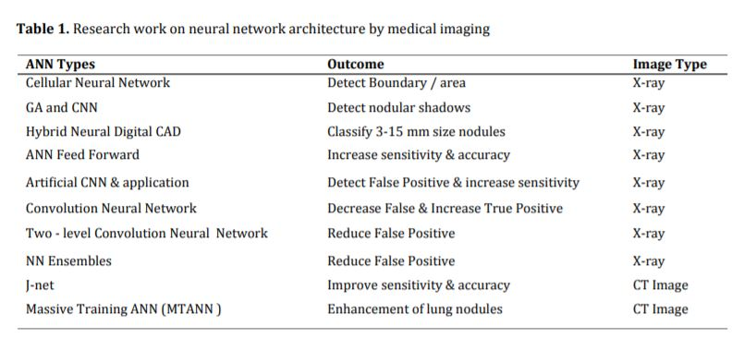Fig 1.12 Research work on neural network architecture by medical imaging [10]

These network tools have proven to be an asset that helps in reducing the amount of work a medical practitioner has to do in terms of detection of rare facts. These networks also provide support in decision making. Table 1 provides us the data regarding the various kinds of algorithms of the different kinds of artificial neural networks have been used by clinicians all around the world. For the classification of cases breast cancer, brain tumour, skin cancer, etc. Although, the above given data, mentioned methods have not succeeded much to credit the vitality of the ANNs generalization aspect.

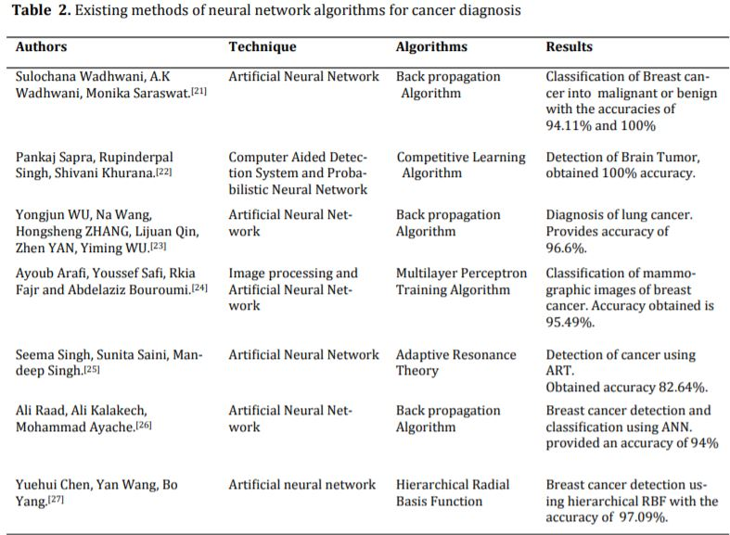

Fig 1.13 existing methods of neural network algorithms for cancer diagnosis [4]

The conclusion drawn here would be that these powerful tools have facilitated the medical practitioners over the years in the area of diagnosis. Decision making and accuracy powers of these networks are satisfactory for not only breast cancer but other diseases also. And even if it does have so many applications being widely deciphered, they must be stated as the final tool for making the decisions for the doctors so that they will be fully authorized and responsible for interpreting the results of these networks and because of these artificial neural networks and their evolutionary applications, the need for getting a biopsy and spending an unnecessary fortune on getting a second look at the diseases have vanished.

We can discuss some of the techniques used- like in Computer Aided Breast Cancer Analysis and detection, which uses statistical features and the artificial neural networks- The focus is upon- mammography, which is known for being single handily the most effective screening practise used for breast cancer. In this methodology, statistical method for feature extraction is adopted. It detects confined masses from the mammograms.

The implementation of this methodology for breast cancer is done by tracking down the exact position of the lump successfully by performing the analysis, taking the consideration of multi-scale breast tissue properties on a statistical basis.

Or, in the convolutional neural network classification methodology for breast cancer detection- deep learning is used. It solves the problem of the most common disease in women suffering from cancer.

It builds an algorithm which can do the identification automatically. It proves whether a person is suffering the disease or not by taking into consideration the images of biopsy. Obviously, the algorithm has to be absolutely accurate as there are lives on stake, an incorrect diagnosis can severe the chances of survival immediately.

Creating awareness concerning Breast Cancer, self-assessment, recurrence prediction, building a neural network algorithm for the diagnosis are all part of the objective of various researchers and their work and this report.

**METHODOLOGY-**

What is Deep Learning?

An initiative of Machine Learning, this term is an approach towards the working of the human mind and its neural networks(biological). Deep neural networks, convolutional neural networks, etc are architectures which are consisting multiple layers, through which the data has to pass through, so that it can give us an output. It serves for the better performance of AI and make its few applications a possibility. Applied to many fields like computer vision and speech recognition, deep learning is an intensive approach.

What is Keras?

An open-source library of the artificial neural networks, which is written in Python. An API of a high-level. It can run much better than others like TensorFlow. Its main application is to make the experimentation run fast and prototyping as it runs without any halt on the GPU and the CPU. It is user-friendly. And it is extensible.

Objective- Creating a breast cancer classification model using an IDC dataset. To accurately detect an image from the histology (study of the microscopic structure of cells and tissues) - as benign or malignant.

In this project, we use python, to build a classification model, which will get trained on about 80% histology images from the dataset for breast cancer. The other 10% data will be kept for validation. We will use a convolutional neural network defined by an open-source library called Keras, and we will name it as CancerNet. This network will get trained on the images from the dataset. Then we will analyse the data with the help of a confusion matrix so that we can check the working of our model. IDC which is known as Invasive Ductal Carcinoma, as studied in the types of breast cancer earlier, which gets formed in the milk duct and spreads to the tissues outside of the milk duct, accounts for about 80% of all the breast cancer cases, it is the most common form of it.

The IDC dataset is downloaded from Kaggle. The packages- matplotlib, imultis, numpy, are downloaded in Python.



Some histology images.

STEPS TAKEN-

1. The downloaded requirements are unzipped at the required location, after downloading the prerequisites. And inside the breast-cancer-classification directory, we create the datasets folder and then inside this we create, another directory named as original:

Using the commands- mkdir datasets, mkdir datasets\originals. The dataset should be unzipped at the original directory.

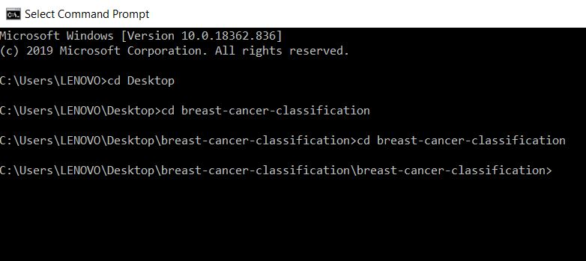

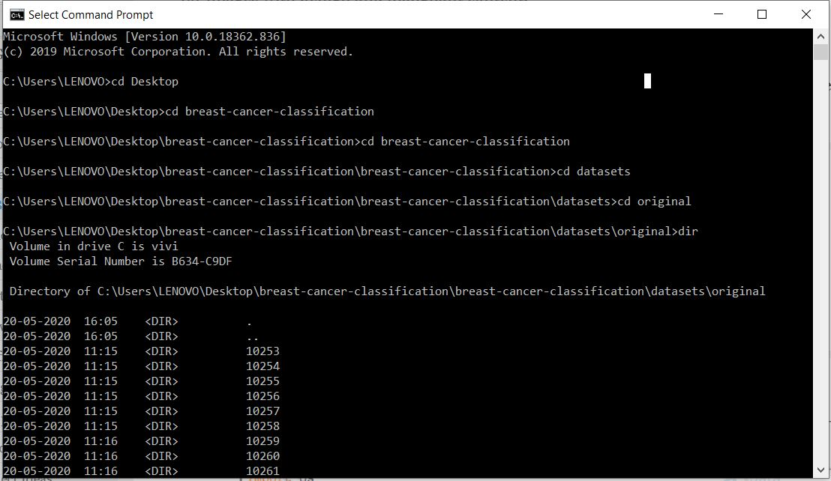

1. The structure of this directory is observed by using the tree command,

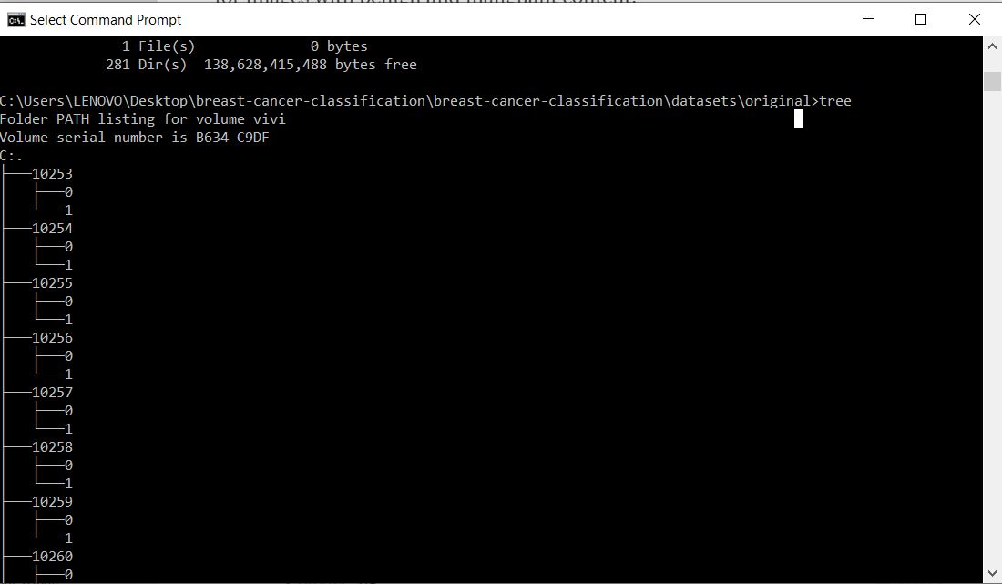

1. Now, we have a directory for all patient IDs and in each of them we have folders- 0 and 1 for images of the benign and malignant tumours.
2. The configuration for building the dataset and training the model-

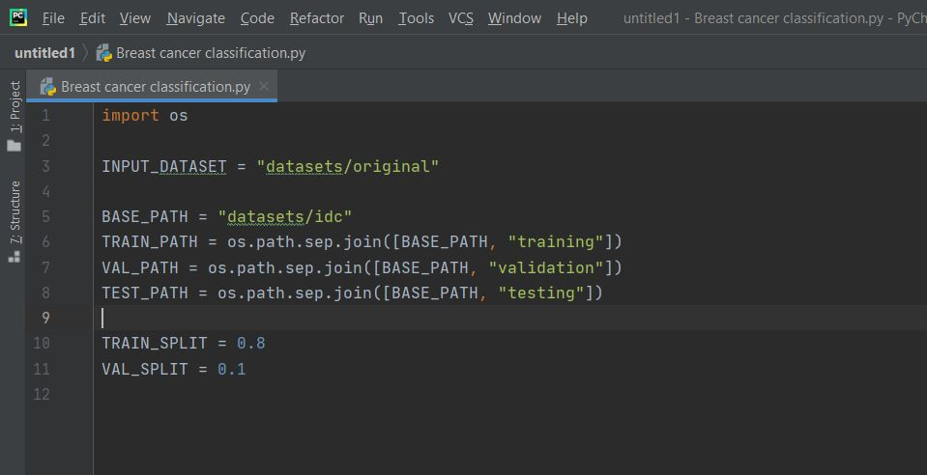

The path is declared for the input dataset, for the new directory, for training, validation, and testing and also we declare the division of the 80% of the dataset for training and 10% for validation.

1. Here, we will import from config, imutlis, random, shutil, and os. A list of the real destinations of the images was created and then mixed up. Then, to calculate the index we multiplied the list length by 0.8 and then made sub-lists for training and testing of the datasets. And further, we repeat the same for the remaining 10% of the list. The dataset contains information regarding the training, validation and testing sets, which carry the path and the base path for everything in the list. “Building testing set” will be created for all the path, base path and setType. A directory is created if a base path does not exist. The extraction of the filename and the label of the class is done. For each path. A directory is created for the label folder 0 or 1, if the path does not exist for it.

Now for the resulting image a path is build so that we can copy the images there.

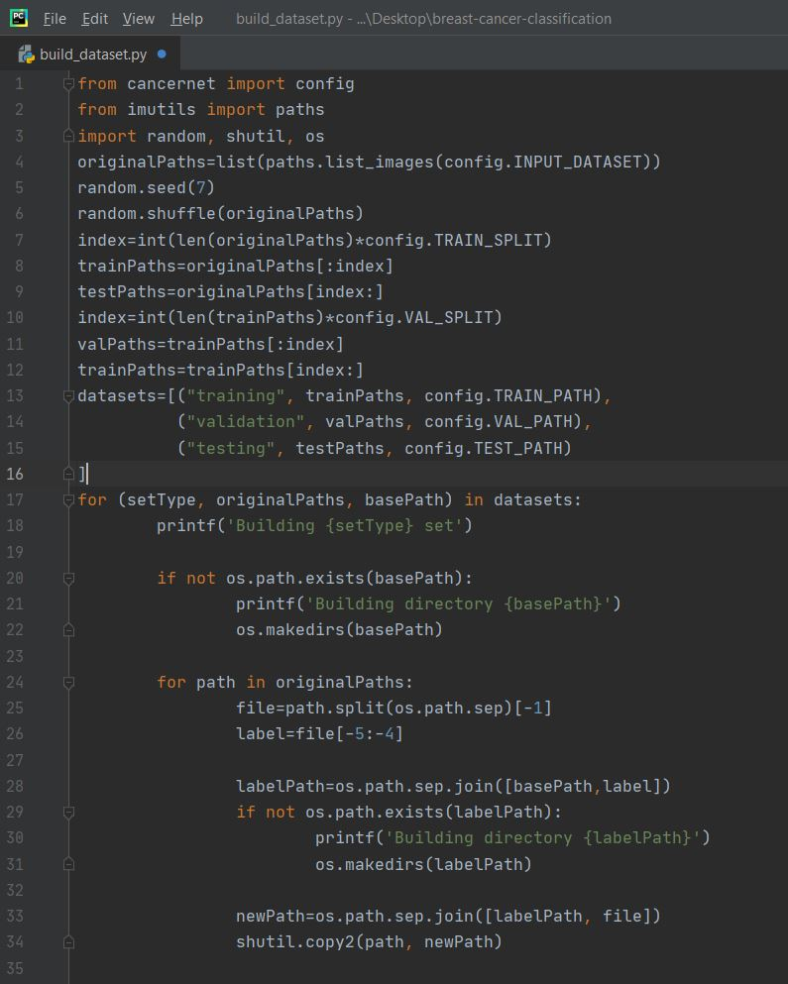

1. The network of the convolutional neural network will now be built and called CancerNet. A sequential API was used to build the network.

To perform the depth-wise convolutions, SeparableConv2D was used.

The class has a method that will include four parameters namely width, height of the images and the depth of the images. The last one is the number of classes the CNN will predict from= 2. Because of 0 and 1.

After performing the tasks of initializing the model, shape and defining the layers, the model is returned.

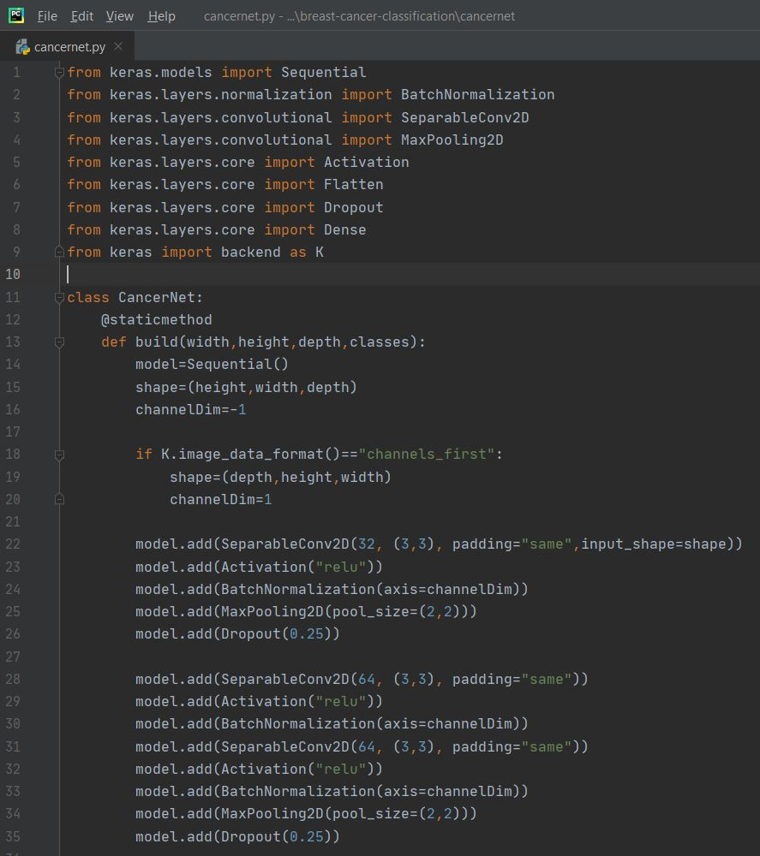

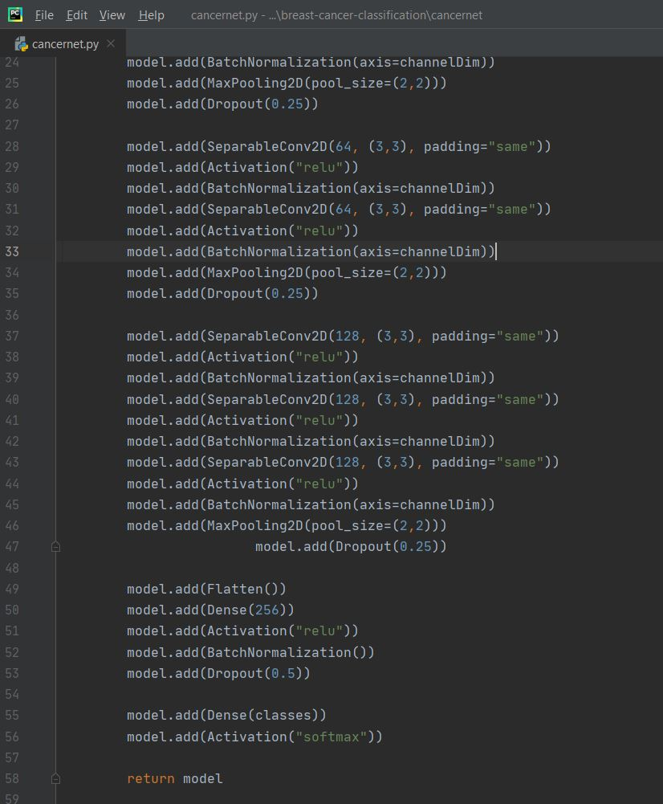

1. The network is now trained, we import from keras, sklearn, cancernet, numpy, matplotlib, etc. Here, firstly we give the values for the number of epochs, rate of learning and batch size. For training, testing and validation, we will obtain the paths. Then, after performing all the functions for our model, we will let it evaluate and work on the data and then compute the confusion matrix, obtain the accuracy and plot it against the training loss.

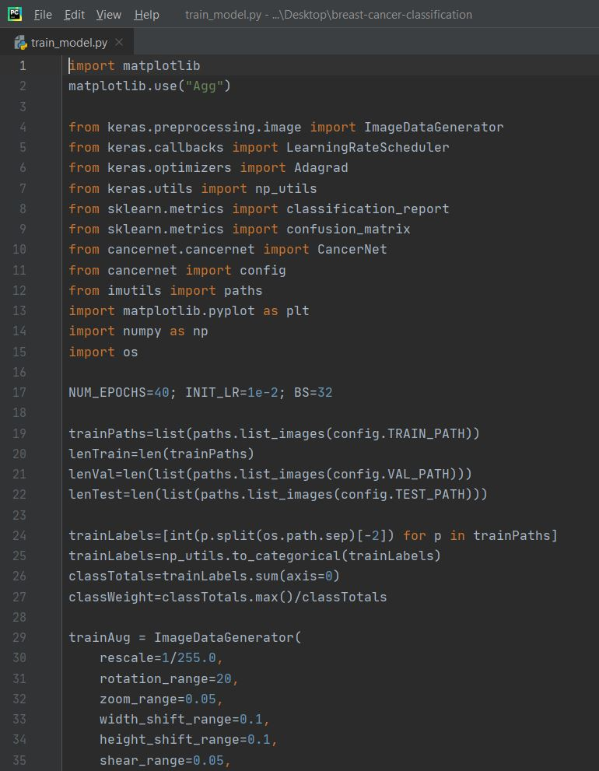

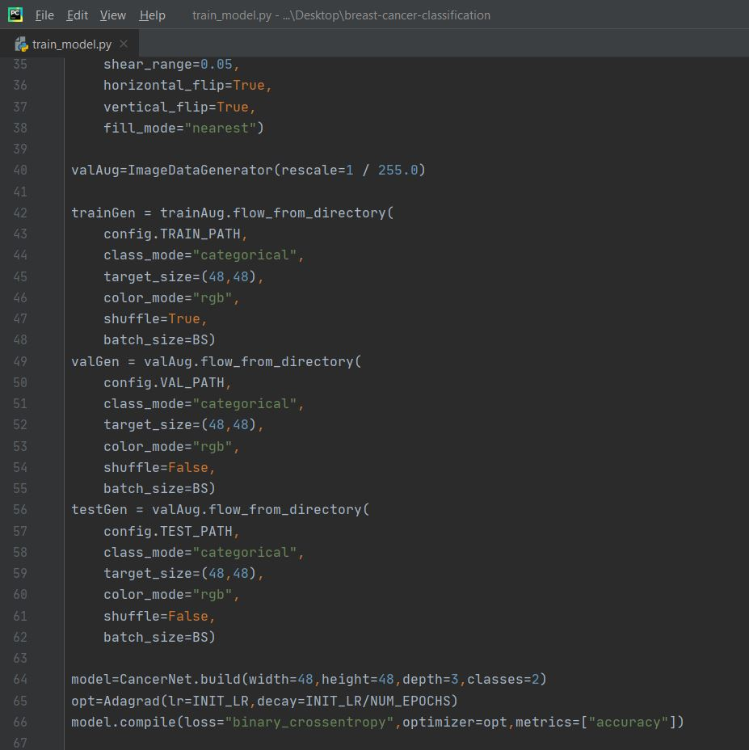

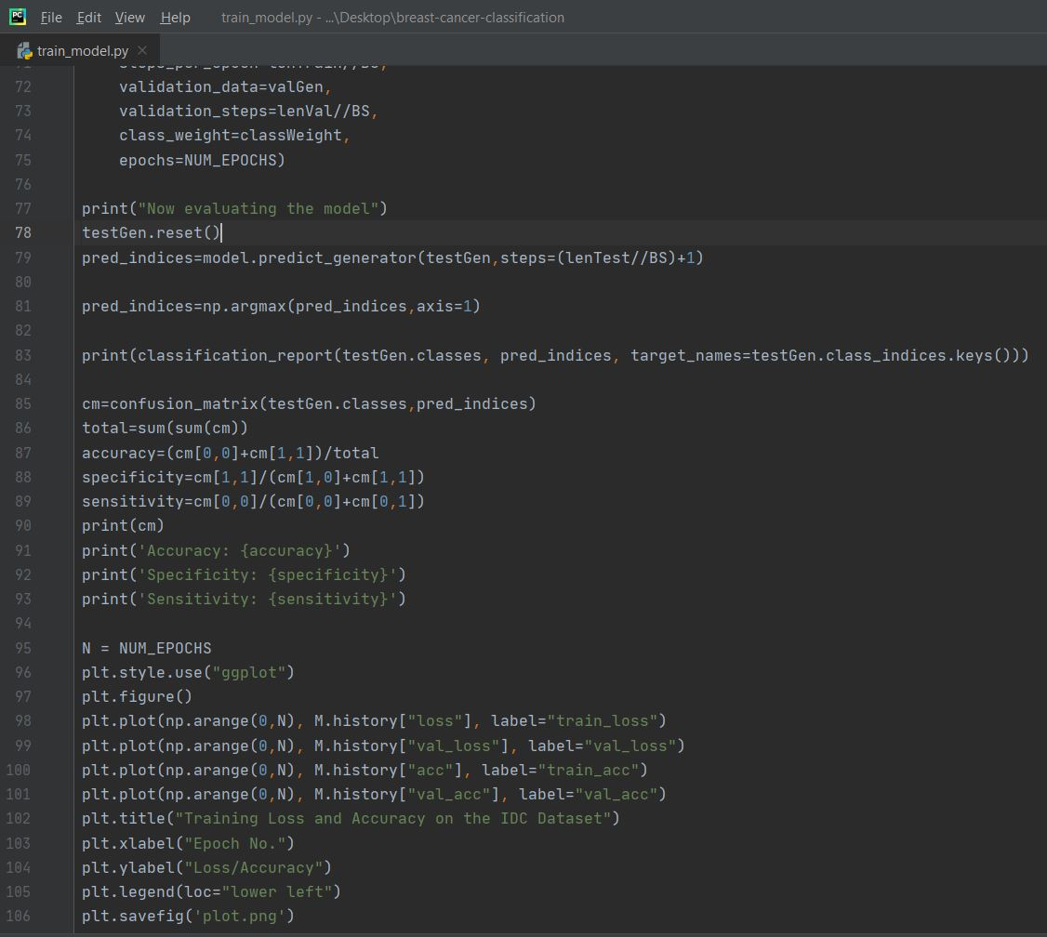

**Results and discussion-**

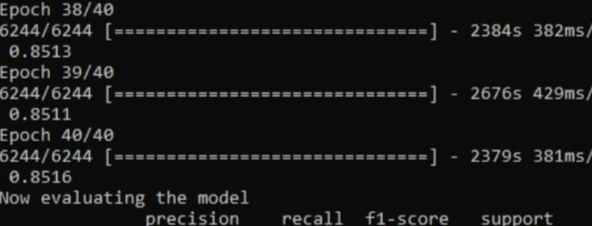We obtain the results as-

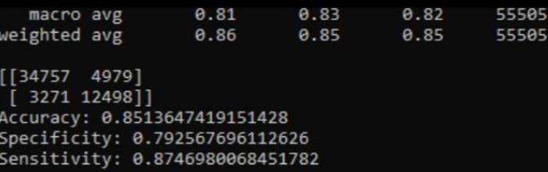

**Conclusion-** In this project we learned about Artificial Neural Networks, their applications in our everyday lives and the its advantages and disadvantages. Then, we ventured upon the field of Breast Cancer and its trends in India, and we built accordingly a classifier using the convolutional neural networks in python. On the IDC dataset, we created the network, trained it and then used Keras to implement the same.

**Future works-** The other types of neural networks could be explored to build a model for the classification and diagnosis of Breast Cancer with a greater accuracy.

**REFRENCES-**

[1] Wu, Yuzheng, et al. "Artificial neural networks in mammography: application to decision making in the diagnosis of breast cancer." Radiology 187.1 (1993): 81-87.

[2] Abbass, Hussein A. "An evolutionary artificial neural networks approach for breast cancer diagnosis." Artificial intelligence in Medicine 25.3 (2002): 265-281.

[3] Lundin, Mikael, et al. "Artificial neural networks applied to survival prediction in breast cancer." Oncology 57.4 (1999): 281-286.

[4] Yao, Xin, and Yong Liu. "Neural networks for breast cancer diagnosis." Proceedings of the 1999 Congress on Evolutionary Computation-CEC99 (Cat. No. 99TH8406). Vol. 3. IEEE, 1999.

[5] Chi, Chih-Lin, W. Nick Street, and William H. Wolberg. "Application of artificial neural network-based survival analysis on two breast cancer datasets." AMIA Annual Symposium Proceedings. Vol. 2007. American Medical Informatics Association, 2007.

[6] Floyd Jr, Carey E., et al. "Prediction of breast cancer malignancy using an artificial neural network." Cancer: Interdisciplinary International Journal of the American Cancer Society 74.11 (1994): 2944-2948

[7] Saritas, Ismail. "Prediction of breast cancer using artificial neural networks." Journal of Medical Systems 36.5 (2012): 2901-2907.

[8] Burke, Harry B., David B. Rosen, and Philip H. Goodman. "Comparing the prediction accuracy of artificial neural networks and other statistical models for breast cancer survival." Advances in neural information processing systems. 1995.

[9] Janghel, R. R., et al. "Breast cancer diagnosis using artificial neural network models." The 3rd International Conference on Information Sciences and Interaction Sciences. IEEE, 2010.

[10] Burke, Harry B., David B. Rosen, and Phillip H. Goodman. "Comparing artificial neural networks to other statistical methods for medical outcome prediction." Proceedings of 1994 IEEE International Conference on Neural Networks (ICNN'94). Vol. 4. IEEE, 1994.